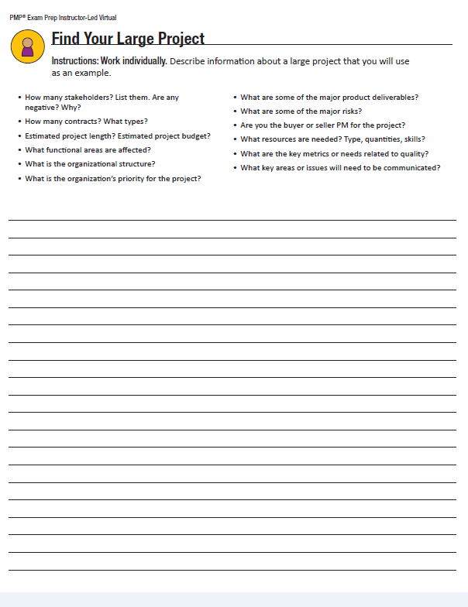

3

**High Level Risks**

* External factors could cause delays and cost overruns on construction that could exceed budget
* There could be unseen delays on the receipt of product/materials from Sweden
* Building and parking permits have been affected by labor disputes and may be delayed
* Library software will be a complicated configuration on the new computers causing difficult configuration and potential delay

**Project Completion Criteria**

The final building cost and schedule will be represented in a report outlining the functionality of the library, how many residents it will service, the budget and tax savings and number of people it will employ. The report will be signed off by the project team and sanctioned by the Office of the Commissioner, the finance department, City Council and the Mayor.

**Project Authorization, Sponsor**

**________________________________**Gerald Maccombe, County Commissioner

**Project Authorization, Co-Sponsors**

**_____________________________ ______________________________**Stephen Baker, Mayor Alfred Whitehouse, Head of City Council